FOR IMMEDIATE RELEASE
THE LIFE CENTER FOUNDATION
APRIL 8, 2024

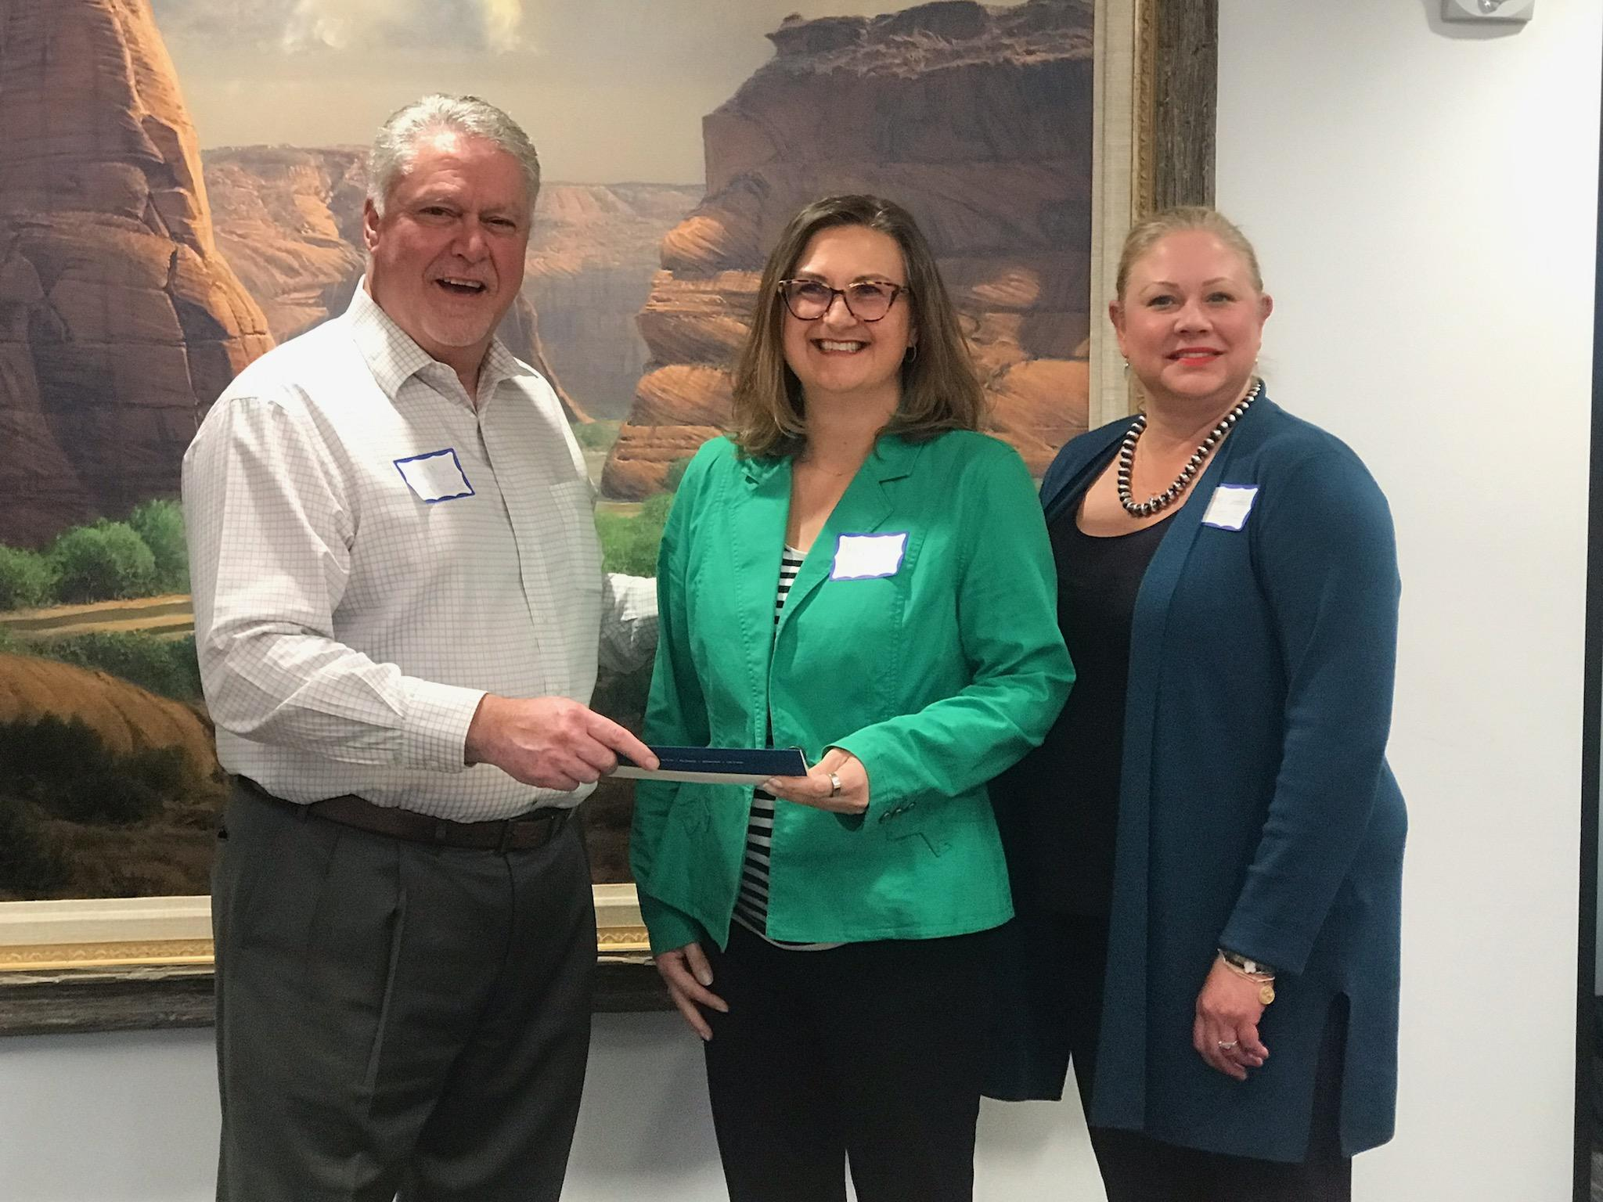
SARANAM HOMELESS SHELTER FOR FAMILIES OF ALBUQUERQUE WAS PRESENTED WITH THE LIFE CENTER FOUNDATION LEADERSHIP AWARD of $20,000 on APRIL 3, 2024 by MAX MYERS, PRESIDENT & CEO, CENTURY BANK, SANTA FE.

The Life Center Foundation, a Public Charitable Foundation, composed of several business leaders and active local citizens has contributed over $500,000 in Grant Awards to NM non-profits on the frontline serving children and teens living in high-risk households, as a result of poverty.

The Leadership Award recognizes an outstanding non-profit organization for their front-line commitment to protect and serve high-risk youth of New Mexico.NM children and teens continue to rank highest in the nation of child homelessness, hunger and domestic violence.1 in 4 NM families receive food assistance with over 700,000 meals being distributed in Santa Fe annually.

This year’s Runners Up have received 2024 Grant Awards. They are: Girls, Inc.; Sky Center, Suicide Intervention Project; Solace Sexual Assault Services.

Sponsors
Anne Hillerman
Century Bank
CRI CPAs & Advisors
Elizabeth A. Sackler
Engel Law Firm
Enterprise Bank & Trust
Gallegos Law Firm
Lisa & Leonard Galante

LCF Board of Directors
Charlotte Montoya-Capling
Linda Hale-Osborne
Marjorie Miller-Engel
Max Myers
Myrna Ruskin
Robert Engel, Esq
Rosalind Milloy
LCF Emeritus Directors
Annette Vigil Hayden
Carol Cochran
Ed Kleiner, MD
The Late Fidel Gutierrez
Lisa Hendrix

For more information please contact Brandon Strel, lifecenterfoundation@gmail.com

